SCHEMA EVOLUTION USING AZURE DATABRICKS AND DATA FACTORY

By

KAILASH S

|  |  |  |
| --- | --- | --- |
| **S.no** | **Content** | **Page number** |
| 1 | Project statement | 3 |
| 2 | Project overview | 3 |
| 3 | Project requirements | 3 |
| 3.1 | Azure Databricks | 3 |
| 3.2 | Azure Data Lake storage | 4 |
| 3.3 | Azure Datafactory | 4 |
| 3.4 | Evolving schema | 4 |
| 4 | Architecture diagram | 4 |
| 5 | Tools used in project | 5 |
| 6 | Prerequisites | 5 |
| 7 | Execution overview | 5 |
| 8 | Implementation on azure portal | 5 |
| 8.1 | Azure account | 6 |
| 8.2 | Create a blog storage account | 7 |
| 8.3 | Create a container | 10 |
| 8.4 | Upload a csv file in container | 11 |
| 8.5 | Creating the azure databricks workspace | 13 |
| 8.6 | Creating a cluster | 14 |
| 8.7 | Creating a notebook | 16 |
| 8.8 | Mounting the storage account in databricks | 17 |
| 8.9 | Transforming data and schema | 19 |
| 8.10 | Converting to pandas data frame | 20 |
| 8.11 | Saving it back to azure storage | 21 |
| 8.12 | Unmount the storage account from databricks | 21 |
| 9 | Creating azure data factory | 22 |
| 10 | Creating a pipeline | 24 |
| 11 | Linking databricks and datafactory | 25 |
| 12 | Review the outcome | 30 |
| 13 | Conclusion | 30 |

**1.Project Statement:** Implement a project where Azure Data Factory handles schema evolution

by moving data to the Data Lake, and Azure Databricks adjusts the schema dynamically based

on the incoming data.

**2.Project Overview:**

This project focuses on utilizing Azure Data Factory (ADF) to handle schema evolution by

moving data to the Data Lake, and Azure Databricks dynamically adjusting the schema based

on incoming data. The goal is to create a flexible and adaptive data processing pipeline that

accommodates changes in the schema seamlessly.

**3.Project Requirements:**

1. Azure Data Factory subscription.

2. Azure Databricks workspace.

3. Azure Data Lake Storage.

4. Data source with evolving schema.

5. Understanding of schema evolution concepts.

**3.1 Azure Databricks:**

Azure Databricks is optimized for Azure and tightly integrated with Azure Data Lake Storage, Azure Data Factory, Azure Synapse Analytics, Power BI and other Azure services to store all your data on a simple, open Lakehouse and unify all your analytics and AI workloads. Azure Databricks is not a traditional ETL (Extract, Transform, Load) tool, but it can be used for ETL purposes. Azure Databricks is a unified analytics platform that is commonly used for big data processing, advanced analytics, and machine learning.

**3.2 Azure Data Lake Storage:**

Azure Data Lake Storage (ADLS) is a cloud-based storage solution provided by Microsoft Azure for big data analytics. It's designed to enable organizations to store and process vast amounts of data in a scalable and cost-effective manner. ADLS is part of the Azure Data Lake, which also includes Azure Data Lake Analytics and Azure HD Insight. ADLS supports different storage tiers, allowing you to optimize costs based on the access patterns of your data. It includes hot, cool, and archive tiers, each with different pricing and performance characteristics.

**Data Lake Storage Gen2:** Azure Data Lake Storage Gen2 is the latest iteration, combining the capabilities of Azure Data Lake Storage Gen1 with Azure Blob Storage. It brings improved performance, lower costs, and a unified storage experience.

**3.3 Azure Data Factory:**

Azure Data Factory is a cloud-based data integration service provided by Microsoft Azure. It allows you to create, schedule, and manage data pipelines that can move data between supported on-premises and cloud-based data stores. Azure Data Factory facilitates the process of data movement and data transformation to enable data-driven workflows for analytics and reporting. Azure Data Factory uses the concept of data pipelines to define a set of data-driven activities. A pipeline consists of a series of data processing steps that move data from source to destination, performing transformations as necessary.

**3.4 Evolving Schema:**

"Evolving schema" typically refers to the ability of a data storage system or database to adapt and accommodate changes to the structure of the data over time. In traditional relational databases, the schema is often fixed and rigid, making it challenging to handle changes to the data model without significant disruptions to existing applications. However, in modern data storage systems and databases, there is a growing emphasis on supporting evolving or flexible schemas.

**4.Architecture Diagram:**

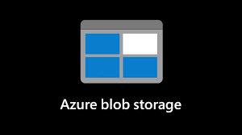



Files

**5.Execution Overview:**

1. Ingest data into Azure Data Factory.

2. Store data in Azure Data Lake Storage.

3. Trigger Azure Databricks to dynamically adjust the schema based on incoming data.

4. Implement a mechanism for schema evolution handling.

Source Date Files

**6. Tools/Technology Used in Project:**

1. Azure Data Factory

2. Azure Databricks

3. Azure Data Lake Storage

4. Data source with evolving schema

**7.Prerequisites:**

1. Azure accounts with necessary subscriptions.

2. Defined data source with evolving schema.

3. ADF linked services for Azure Databricks and Data Lake Storage.

**Implementation - Tasks Performed:**

1. Data Ingestion in Data Factory:

○ Create a pipeline with a copy activity

○ Enable schema drift for the source dataset

○ Define a sink dataset in Data Lake Storage Gen2

2. Schema Adjustment in Databricks:

○ Create a Databricks notebook

○ Read data from Data Lake Storage into a Delta Lake table

○ Utilize Delta Lake&#39;s schema evolution capabilities to handle new or changed

Columns

3. Data Processing and Analysis:

○ Perform necessary transformations and analysis using Databricks capabilities

**Practically Implement on Azure Portal:**

Step 1 - ADF Pipeline Execution - Execute the ADF pipeline for data ingestion.

Step 2 - Data Lake Storage Confirmation - Verify data storage in Azure Data Lake Storage.

Step 3 - Databricks Dynamic Schema Adjustment- Execute the Databricks notebook for

dynamic schema adjustment.

Step 4 - Monitoring Dashboard - Monitor the dashboard for schema changes and update the

Databricks notebook as needed.

**8. Login to Azure Portal:**

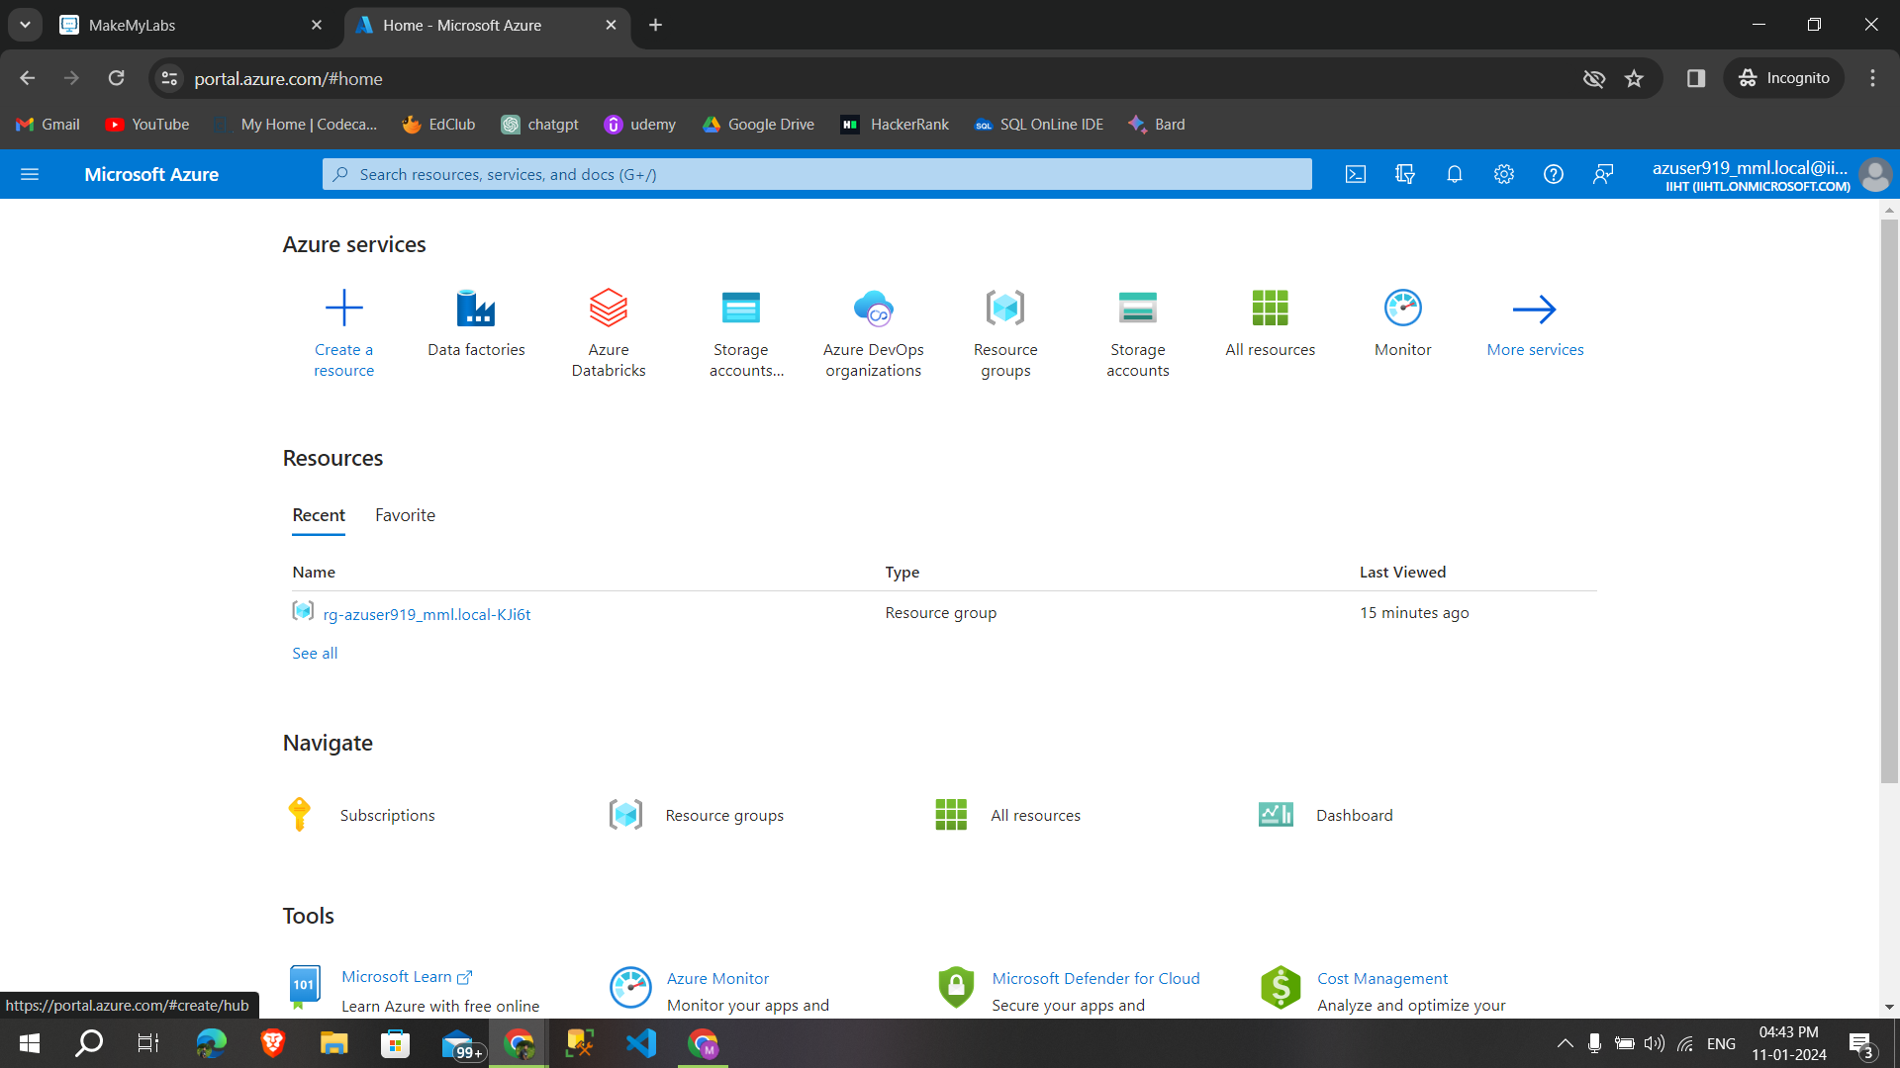

**8.2. Creating Azure Storage Account:**

**Step1: Create** a storage account give appropriate resource group,name,region then **click→advanced**

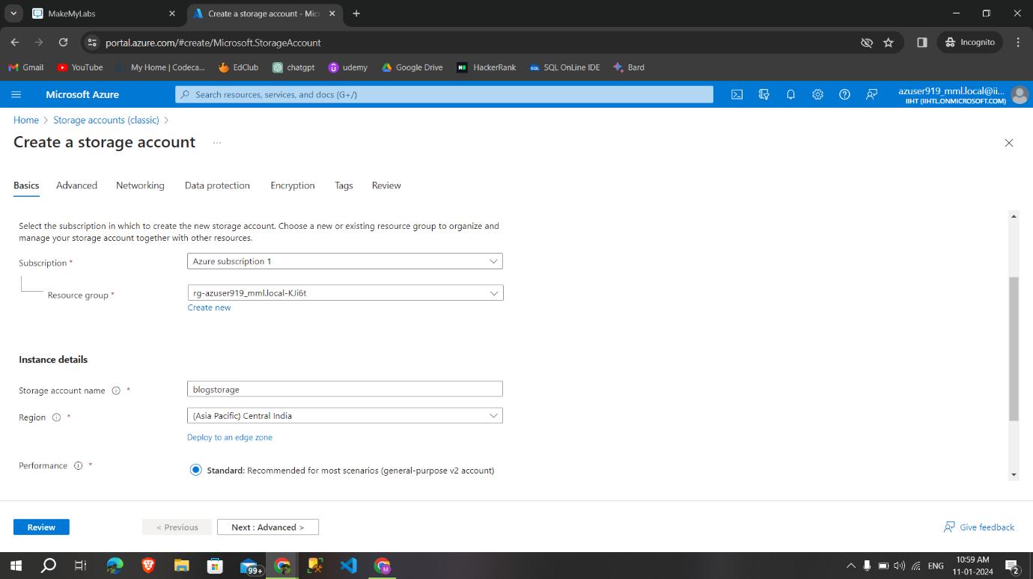

**Step2: Enable** hierarchical namespace if needed then **click →networking**

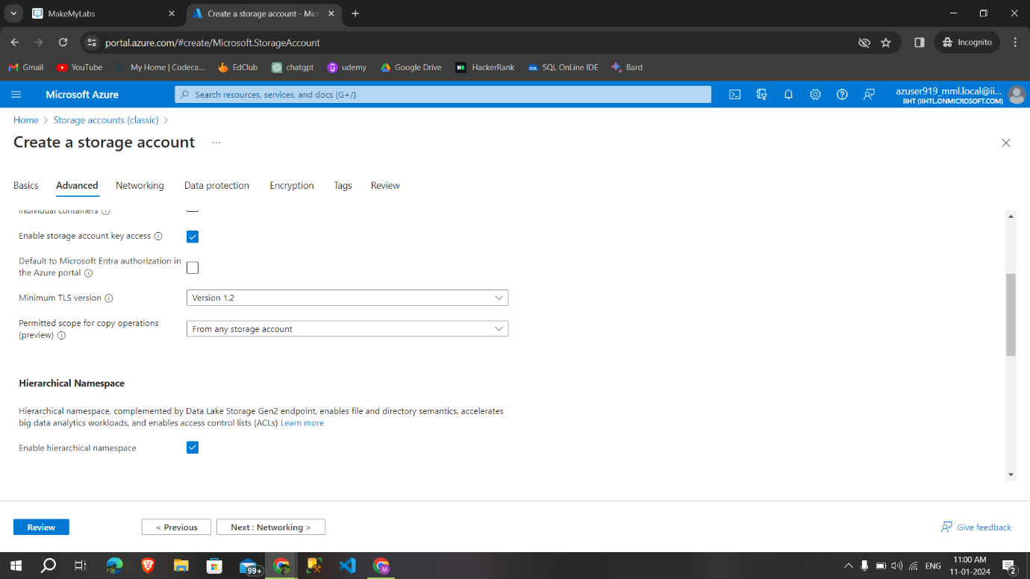

**Step3**: After networking click on data protection for next steps,

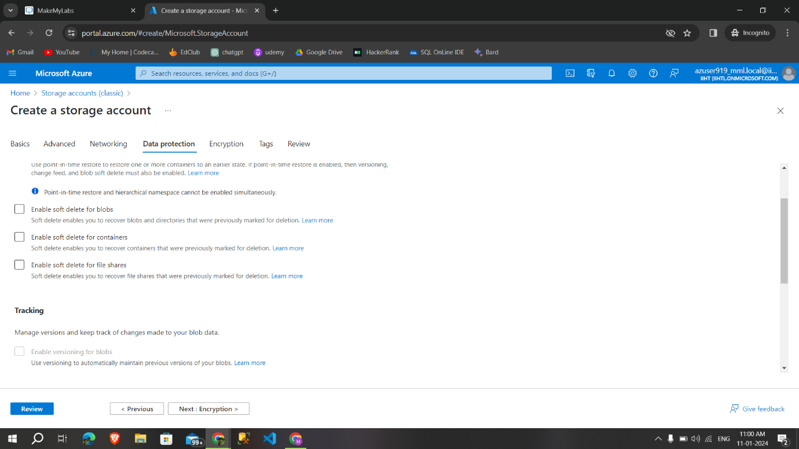

**Step 4: Then** give the encryption type and **click→tags→review**

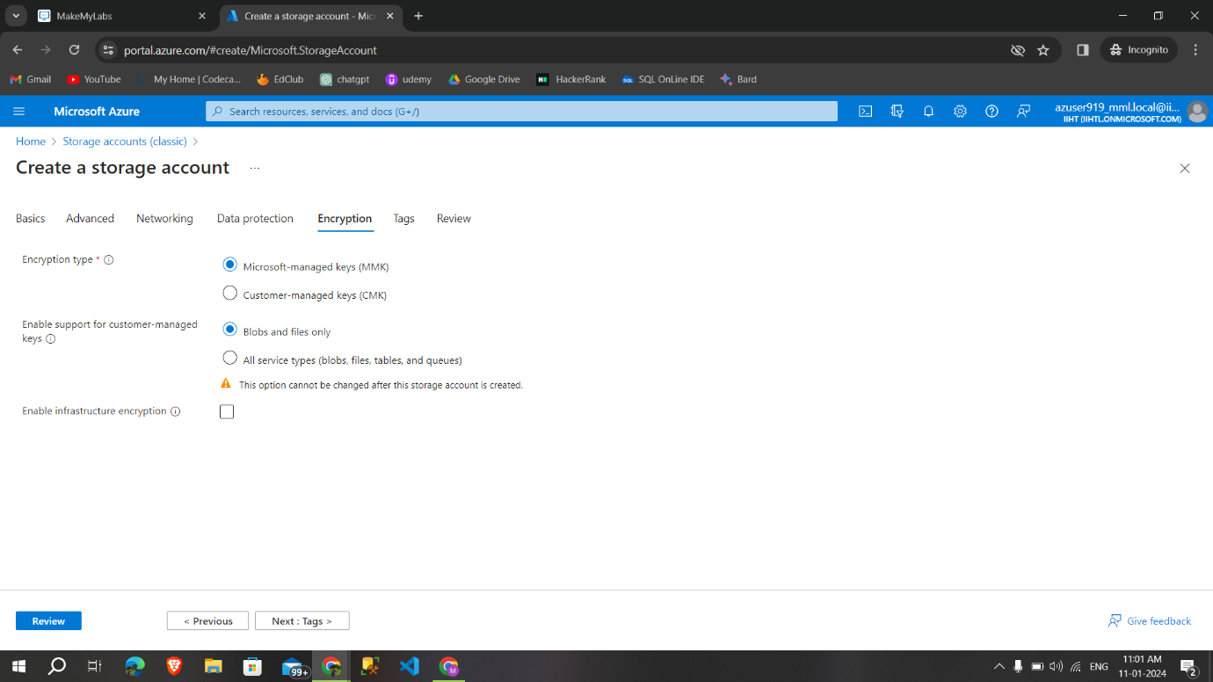

**Step 5:** After reviewing **click →create, to** create a storage account

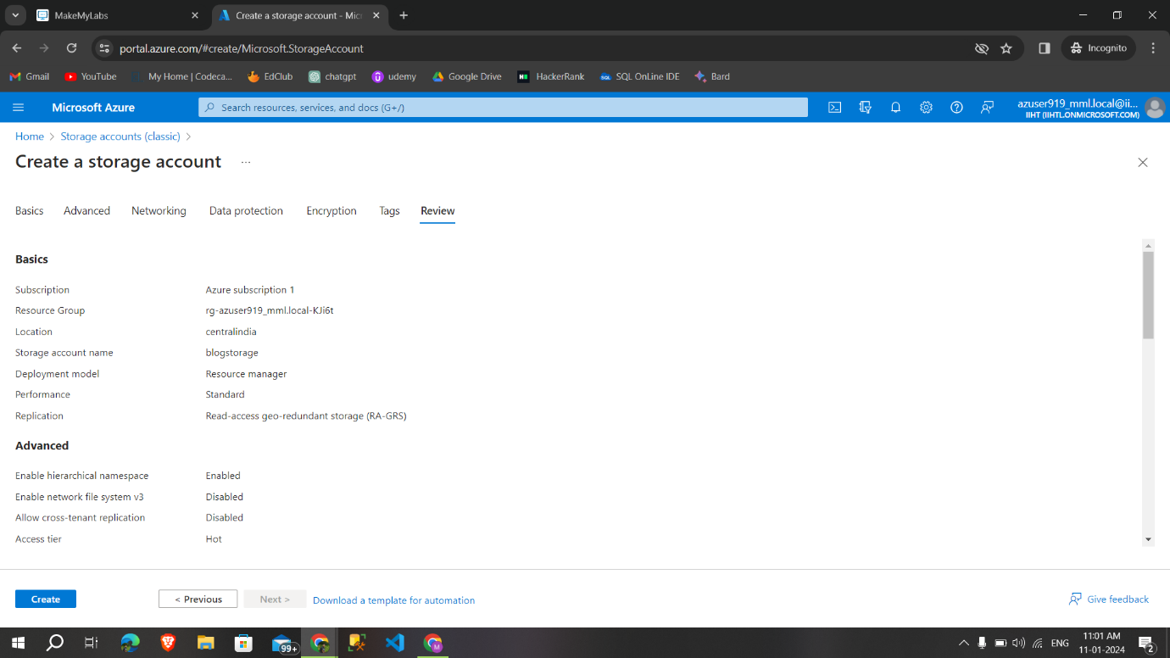

**Deployment is complete**, created a storage account.

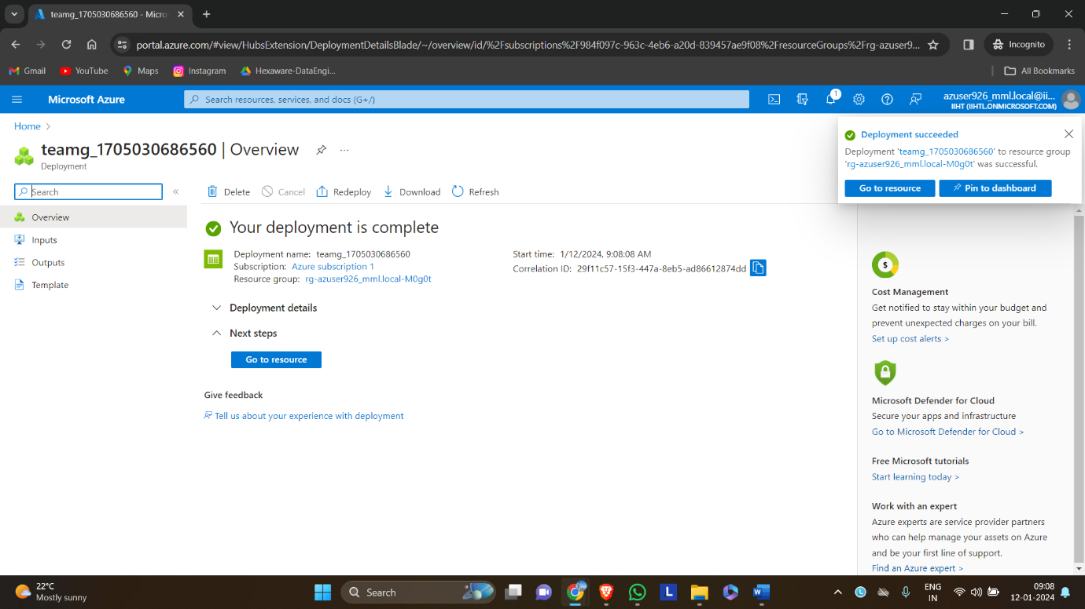

**8.3. Create a container**

**Step 1:** Click on containers to create a blog container

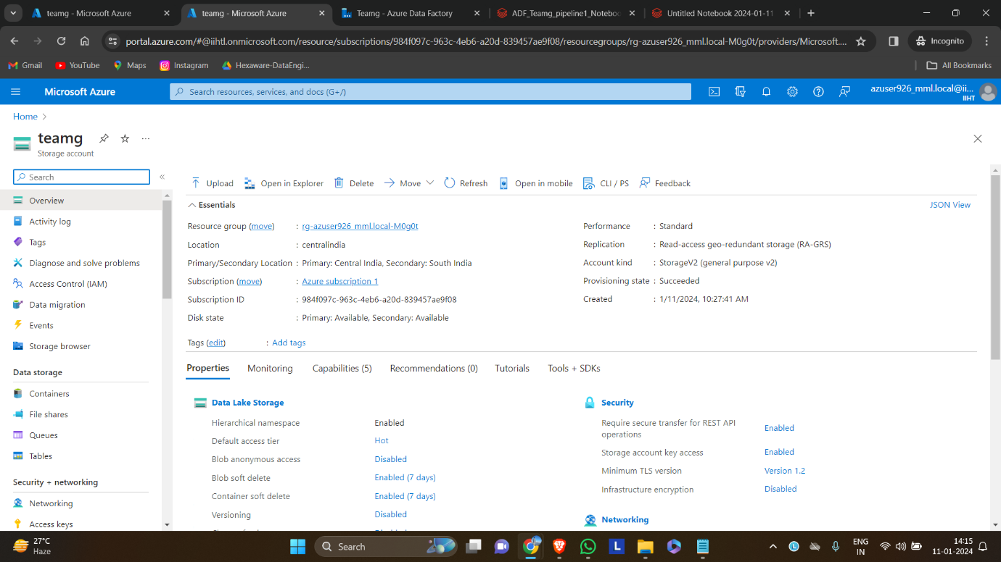

**Step 2:** Select container to create a new container

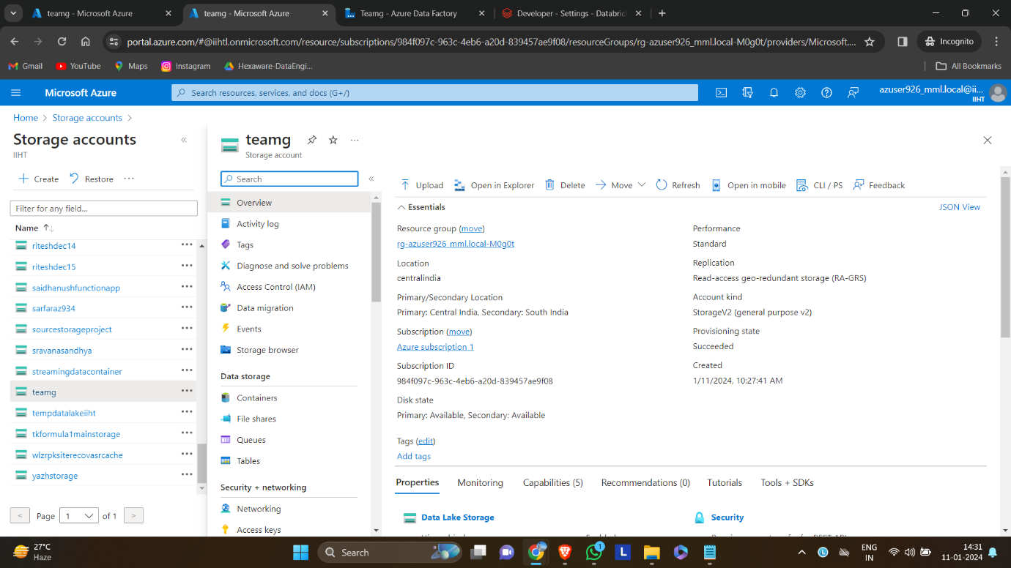

**Step 3:** Give a specific name(project) to your container and click on create

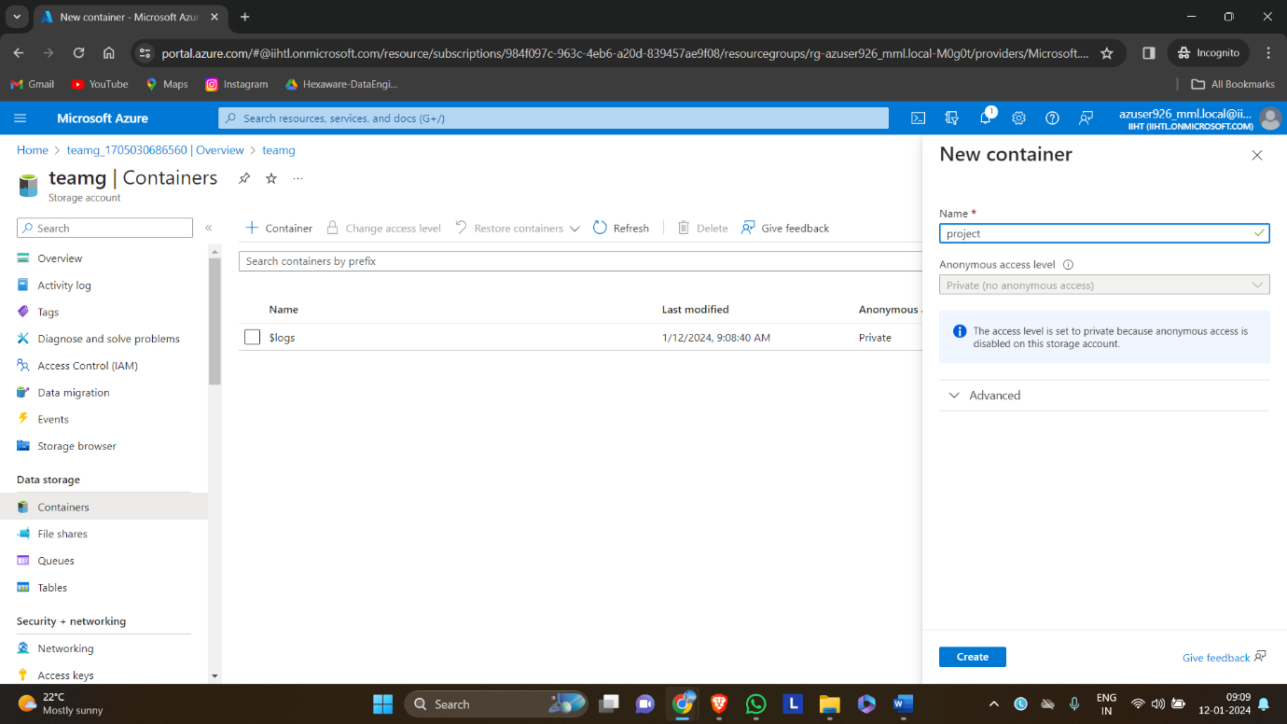

**8.4. Upload a csv files in container**

**Step 1:** Select upload option to upload time stamped data for analysis

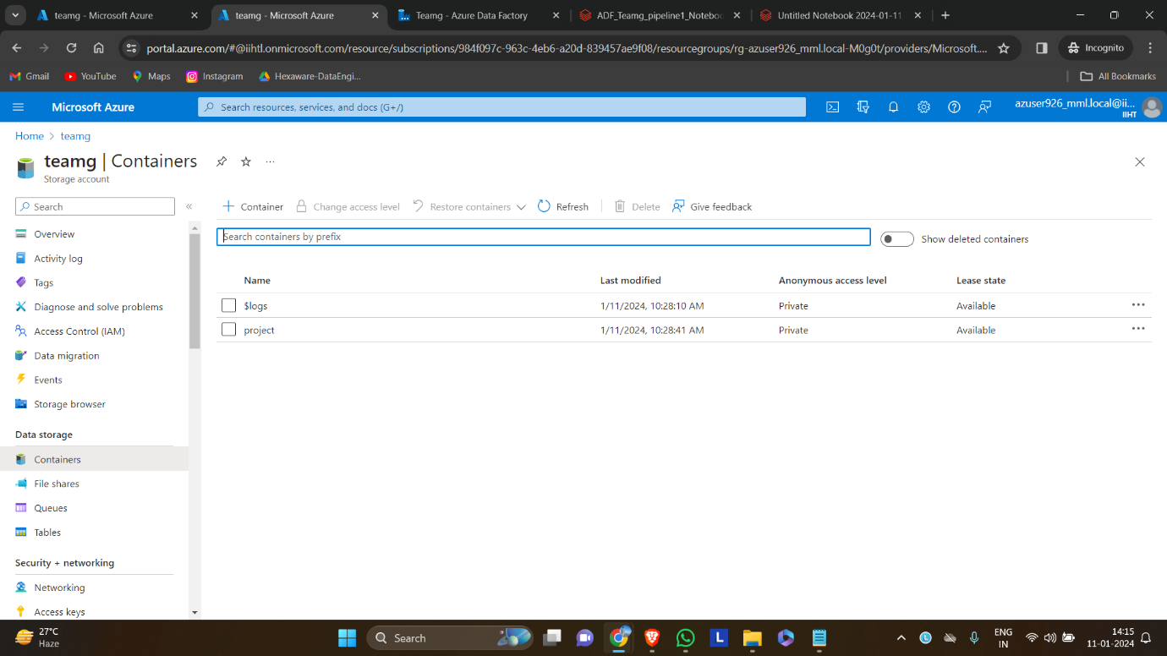

**Step 2:** Uploaded two files in the container

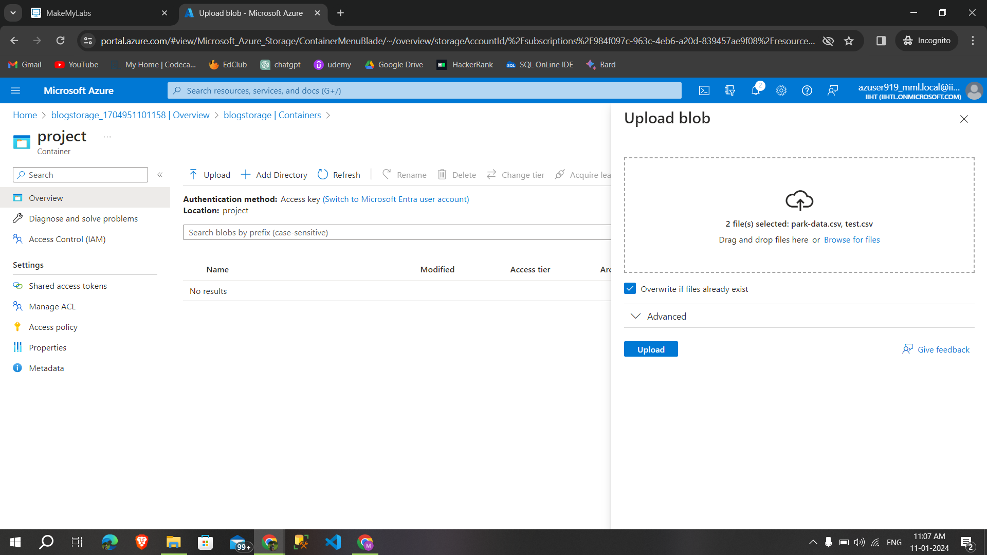

**Step 3:**Successfully added data files

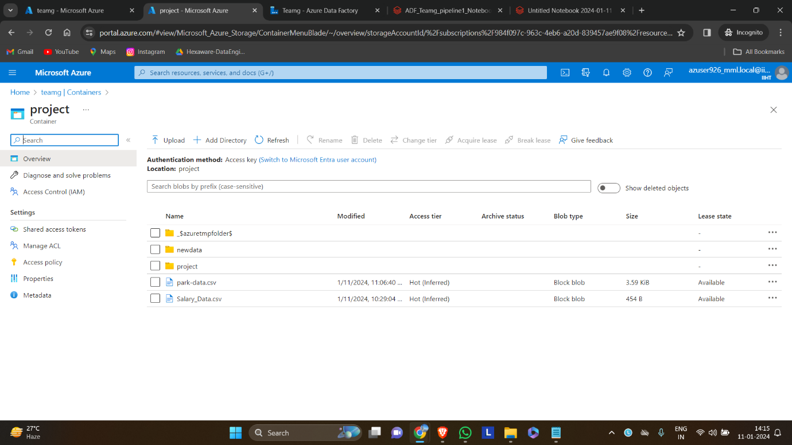

**8.5 Creating Azure Databricks Workspace:**

**Step 1:** Search azure databricks in the azure portal and select create to create a databricks Workspace

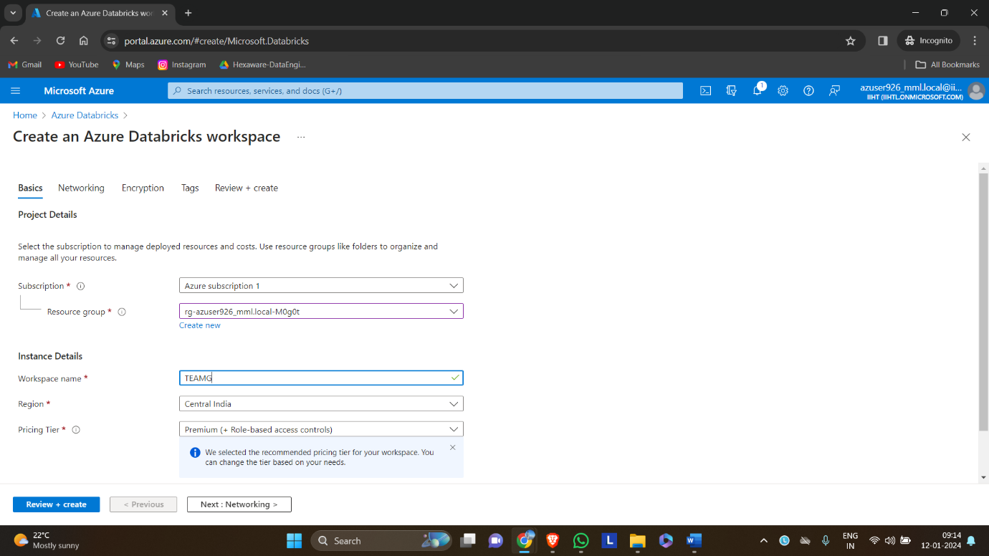

**Step 2**: After giving details like resource group, workspace name,region,pricing tier select→networking

**Step 3:** Click on next and review and create

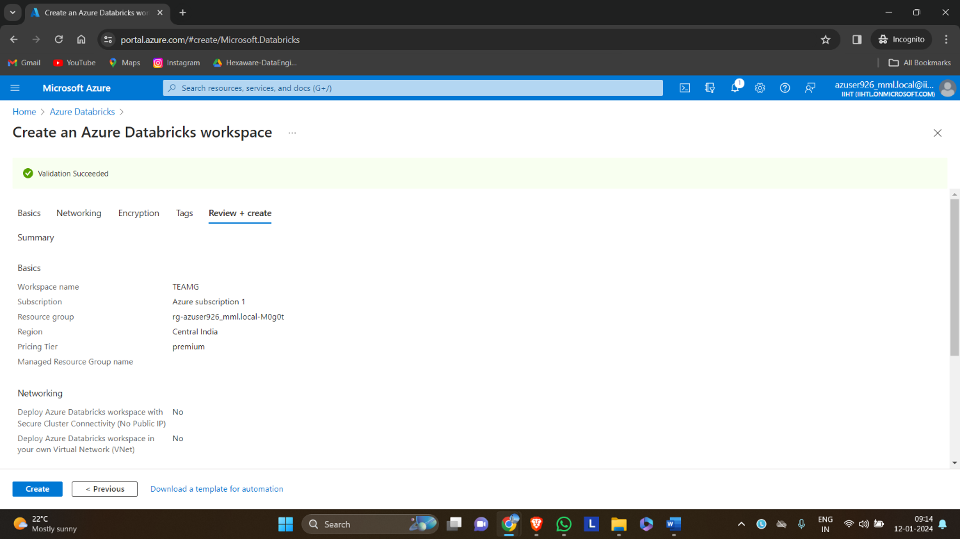

**Step 5:** Deployment is complete now click on go to resource

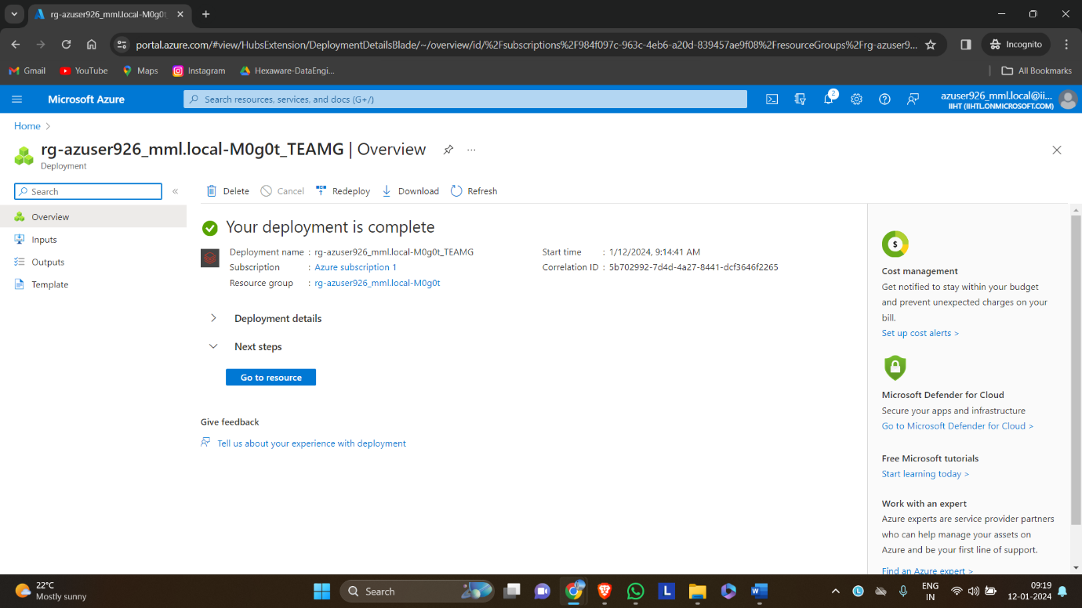

**8.6 Creating a cluster:**

**Step1:** In azure databricks, click launch workspace.

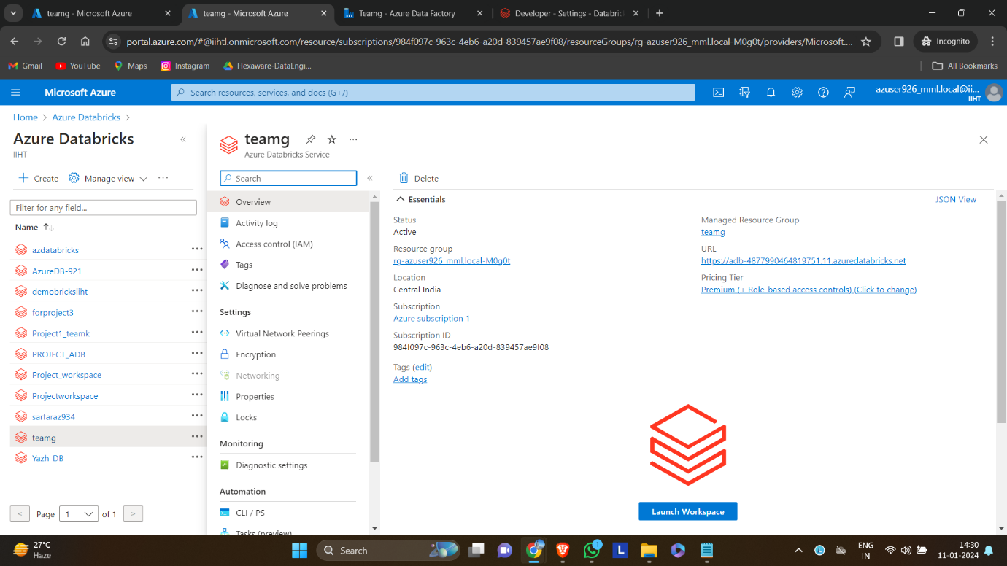

**Step 2:** This is the overview page of databricks workspace select compute to create a new cluster

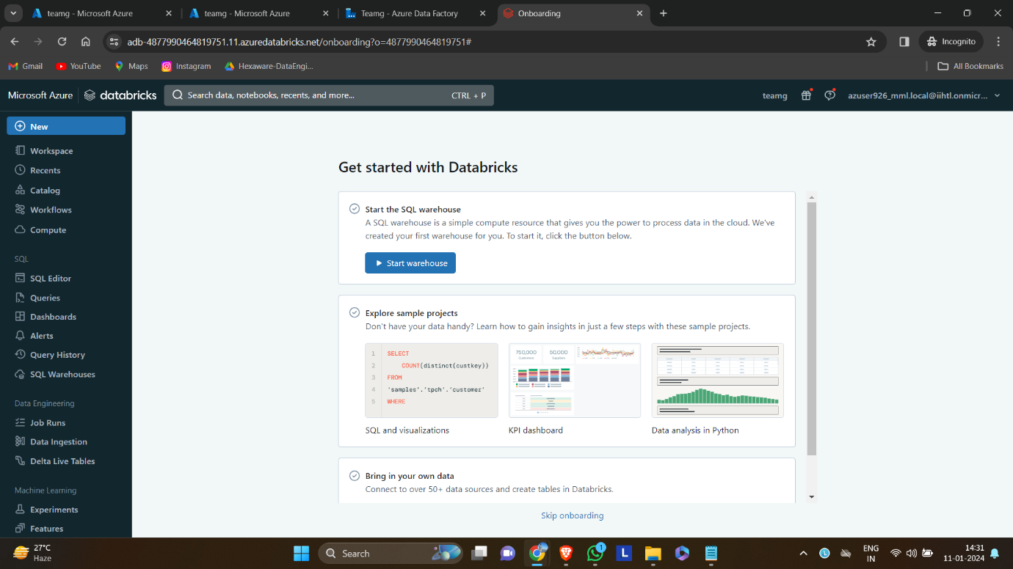

**Step 3:** Select the policy, runtime version, node type and click create compute to create cluster

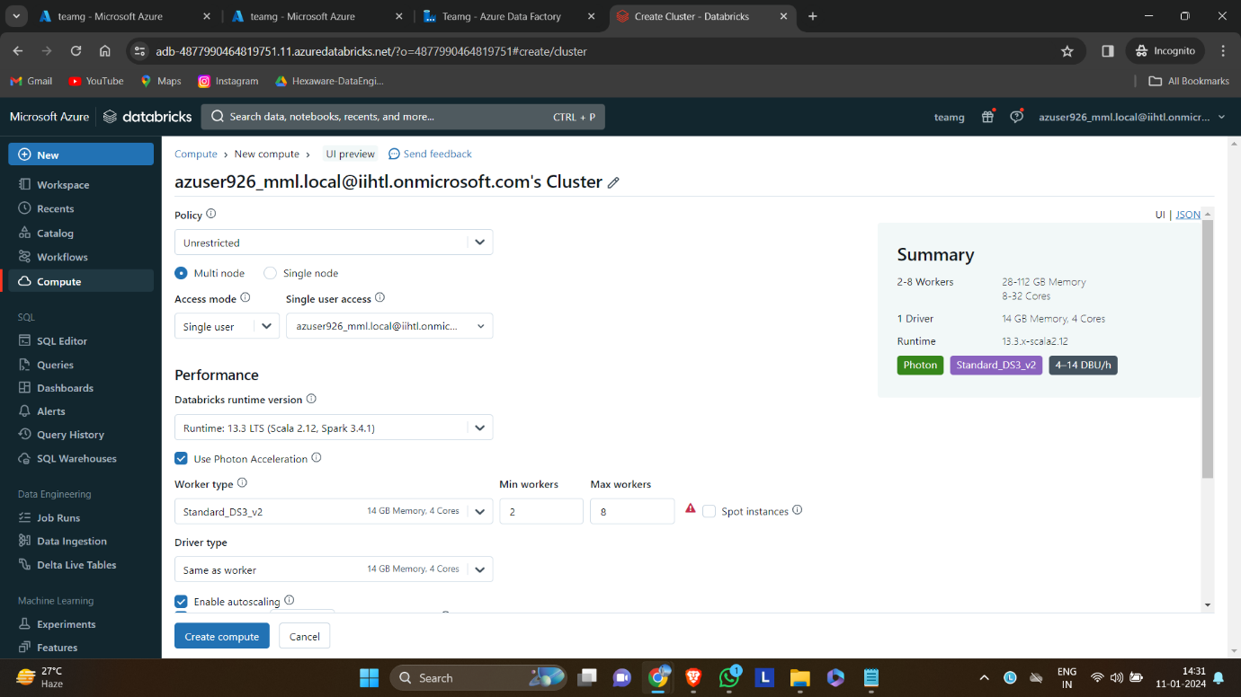

**Cluster is created successfully**

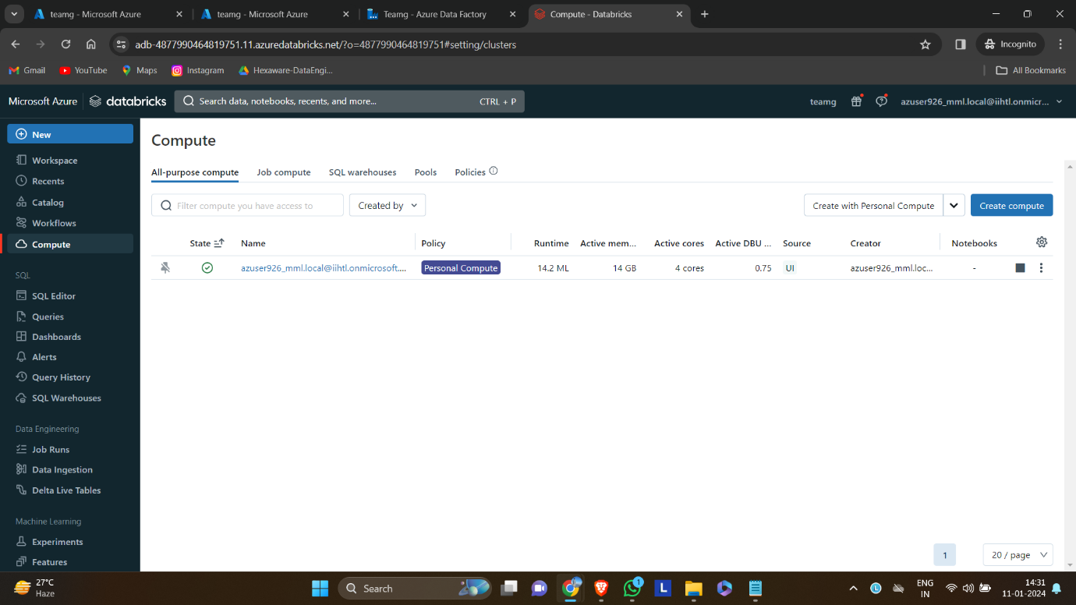

**8.7Creating a notebook**

* create a new notebook by clicking on new→notebook

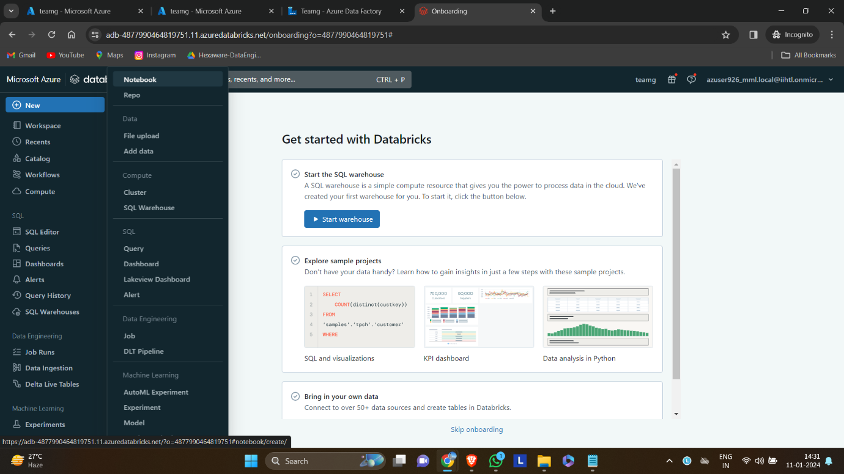

**8.8. Mounting the storage account in databricks**

**Step 1:** By using the dbutils command we can mount the storage account into the azure databricks with the help of access key

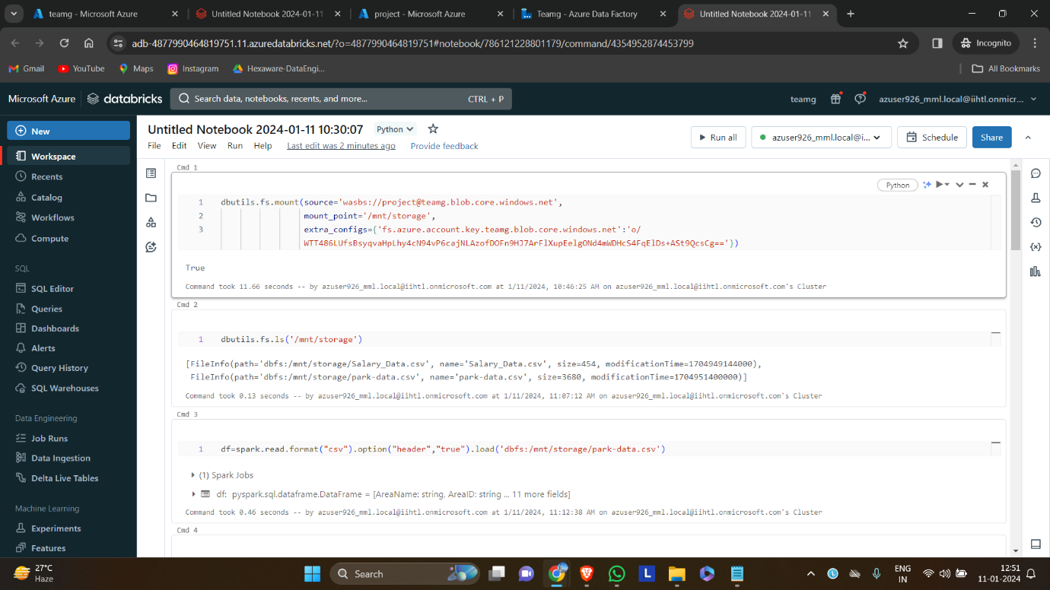

**Syntax for mounting the storage into databricks.**

* dbutils.fs.mount(source=’wasbs://containername@storageaccountname.blob.core.windows.net’,mount_point=’/mnt/mountpointname’,extra_configs={‘fs.azure.account.key.storageaccountname.blog.core.windows.net’:’access key’})

**Syntax for knowing how many files are in storage account are,**

* dbutils.fs.ls(‘mountpointname’)

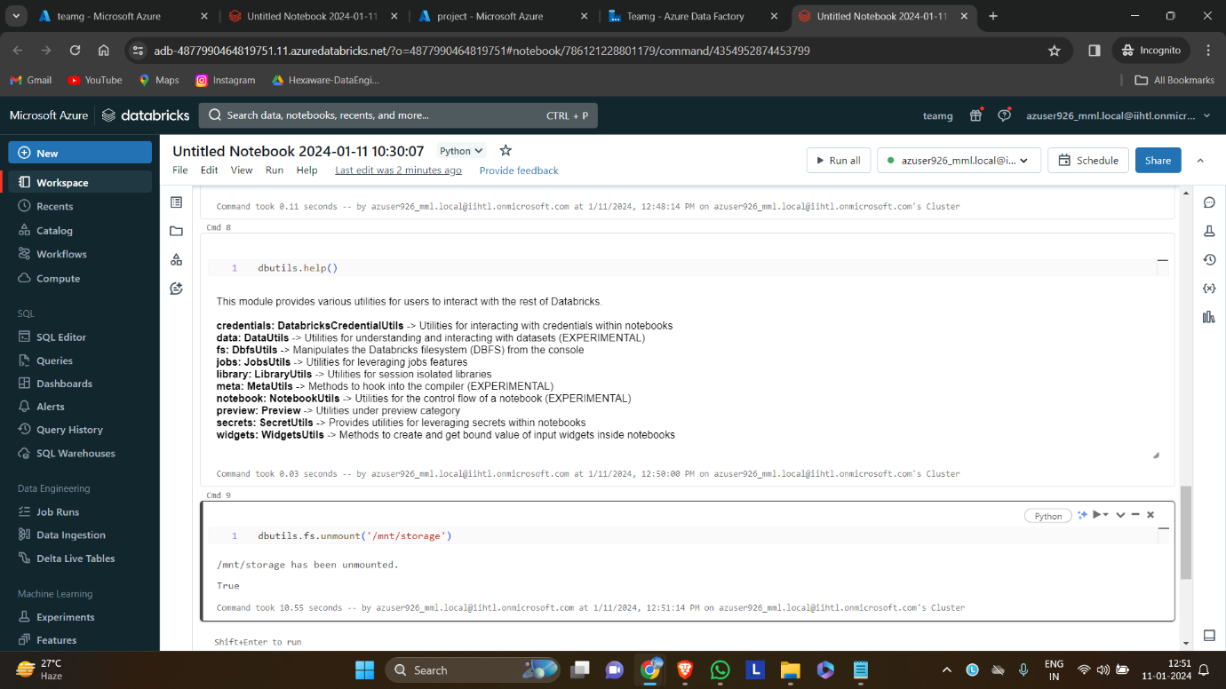

**Step 2:** We can able to the files that are in the storage account

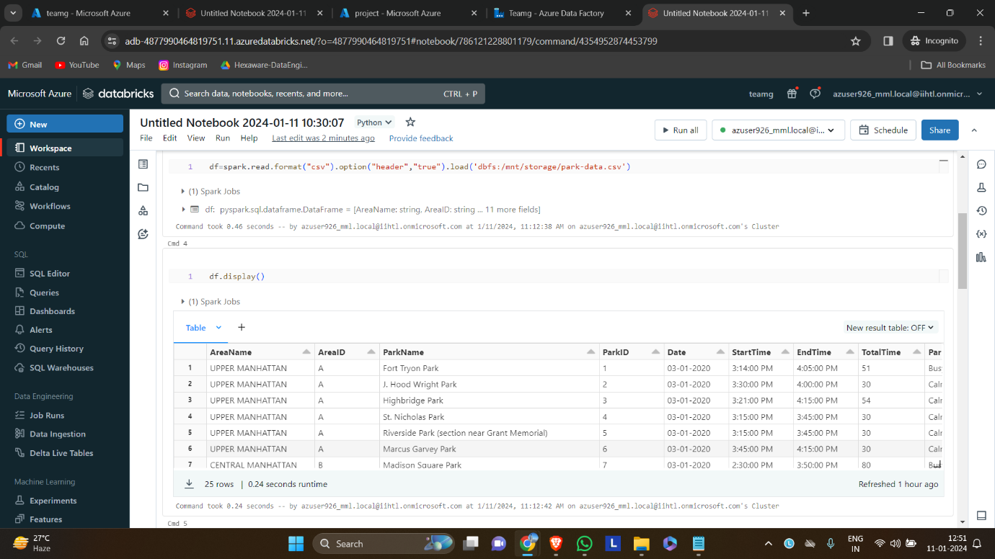

**Step 3:** read one of the files from storage account and displaying it,

**Syntax for reading a csv file:**

df.spark.read.csv(‘path/to/file/’,header=True,inferschema=true)

display(df)

**Syntax for creating a temporary view:**

df.createOrReplaceTempView(“name”)

**Step 4:** Altering the structure of the schema by dropping and creating new columns

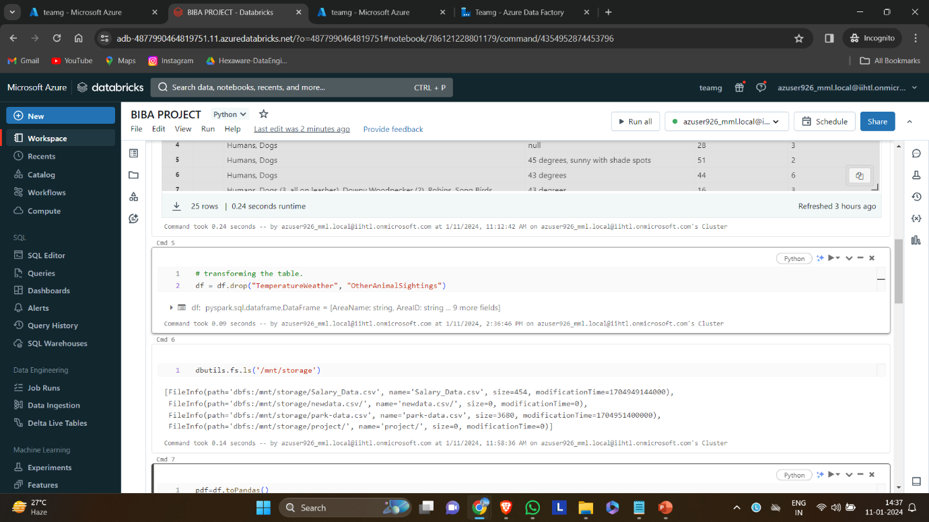

# transforming the schema

df = df.drop("TemperatureWeather", "OtherAnimalSightings")

**Step 5:** converting the dataframe into pandas dataframe to save in the storage directory.

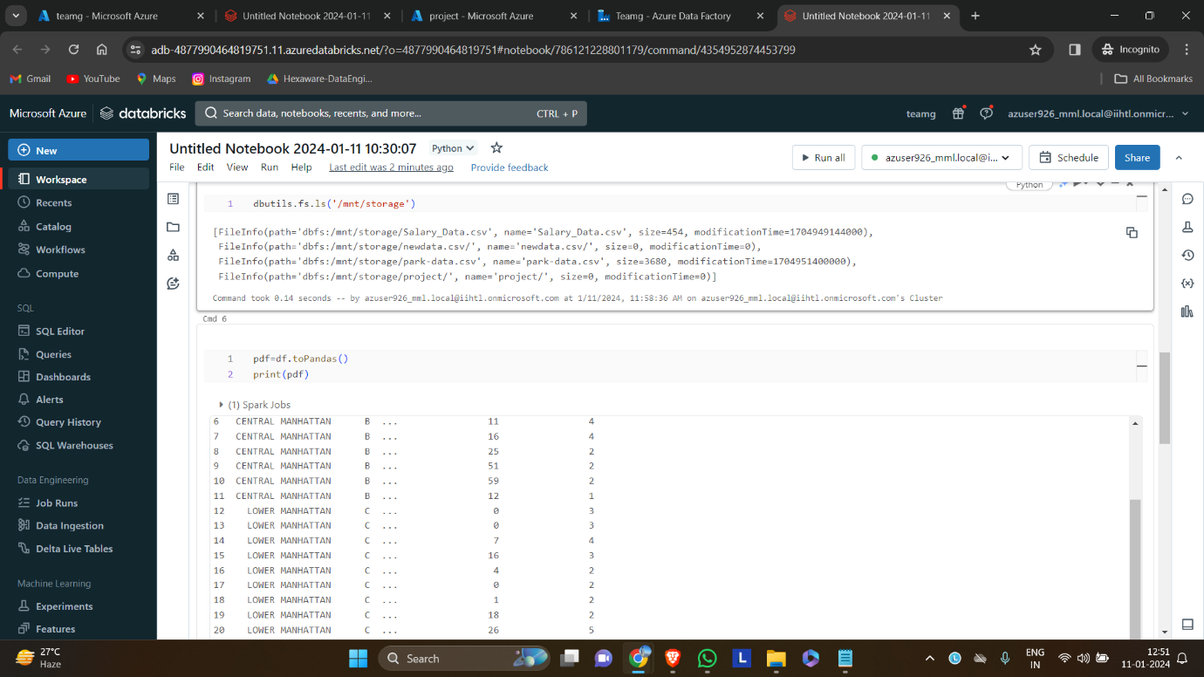

**Step 6:** Storing the dataframe in the azure storage directory.

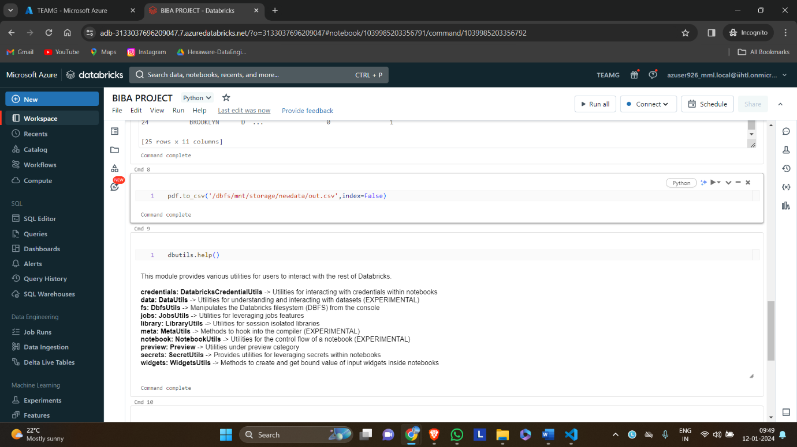

Syntax:

pdf=df.toPandas()

print(pdf)

pdf.to_csv('/dbfs/mnt/storage/newdata/out.csv',index=False)

**Step 7:** Unmounting the storage account.

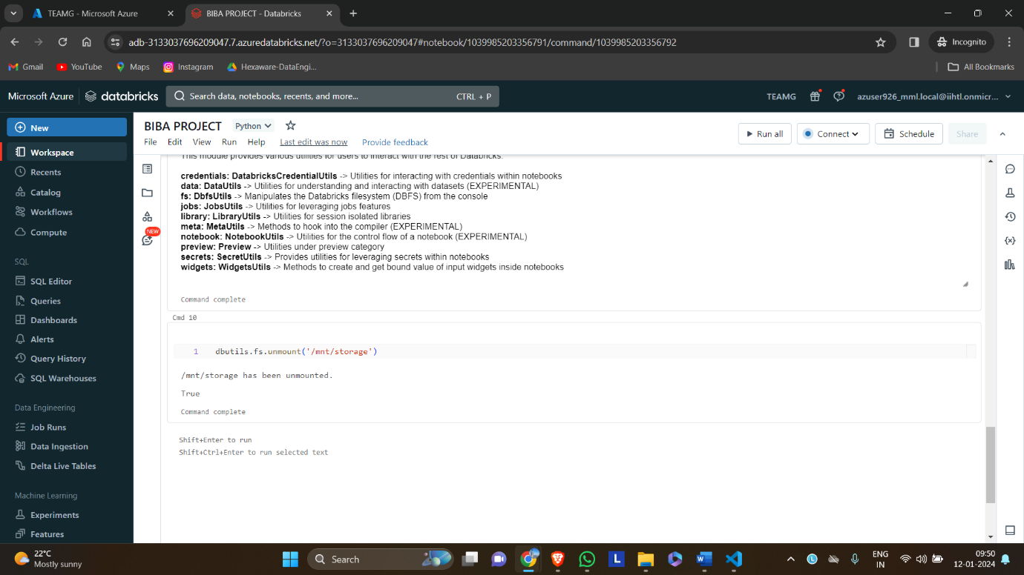

Syntax:

dbutils.fs.unmount('/mnt/storage')

**9.CREATING AZURE DATAFACTORY STUDIO:**

**Step 1:** Create new data factory studio in azure datfactory.

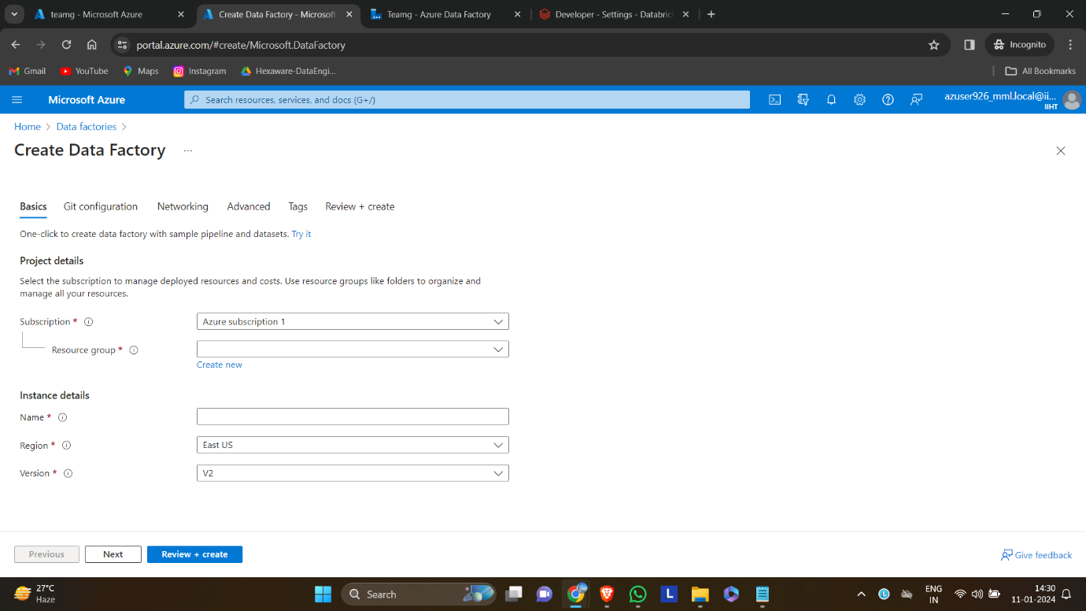

**Step 2:** After deployment go to the resource and click launch studio.

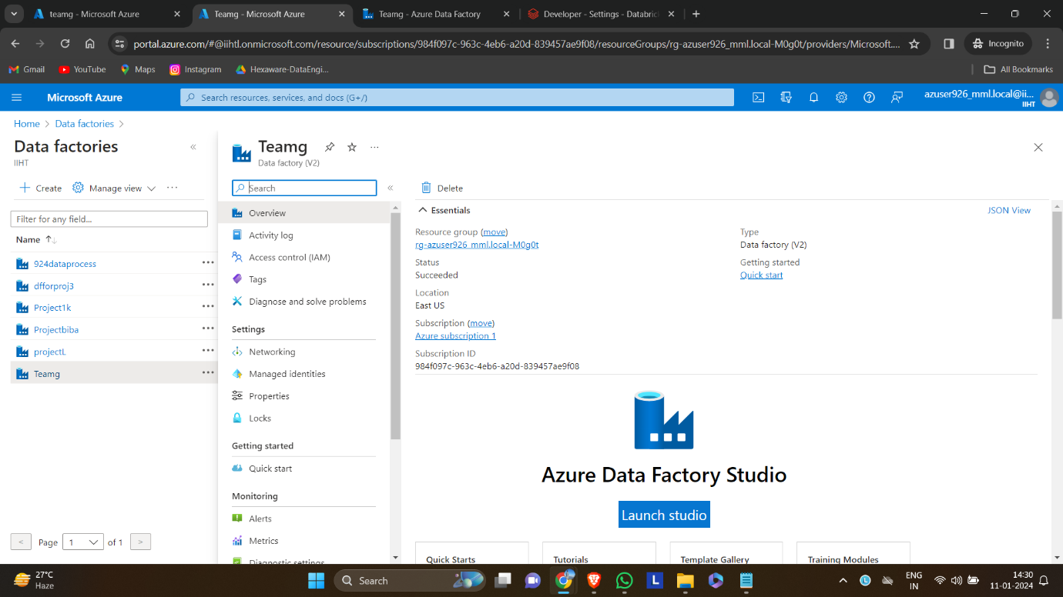

**10.CREATE PIPELINE:**

**Step 3**: Create pipeline by clicking factory resources > pipelines> new pipeline

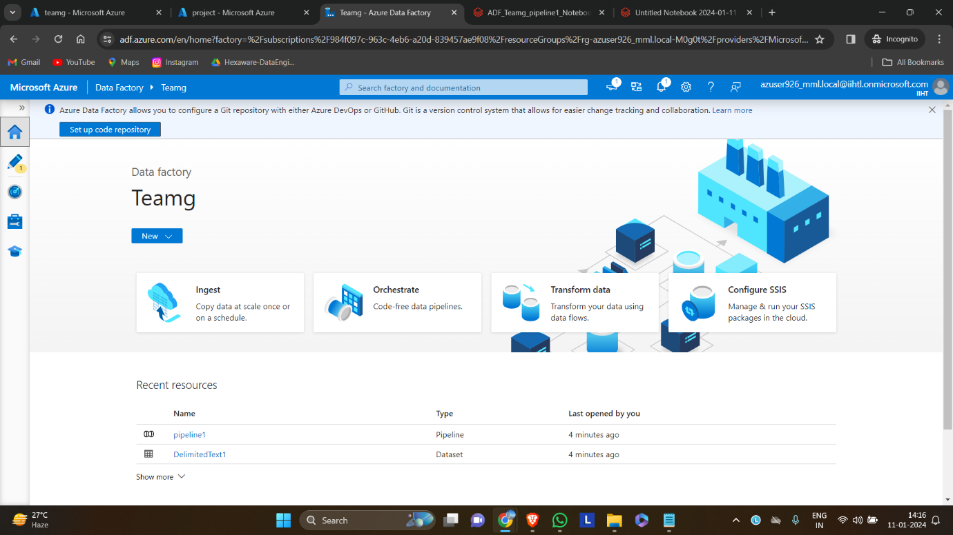

**Step 4:** In activities search for data bricks.

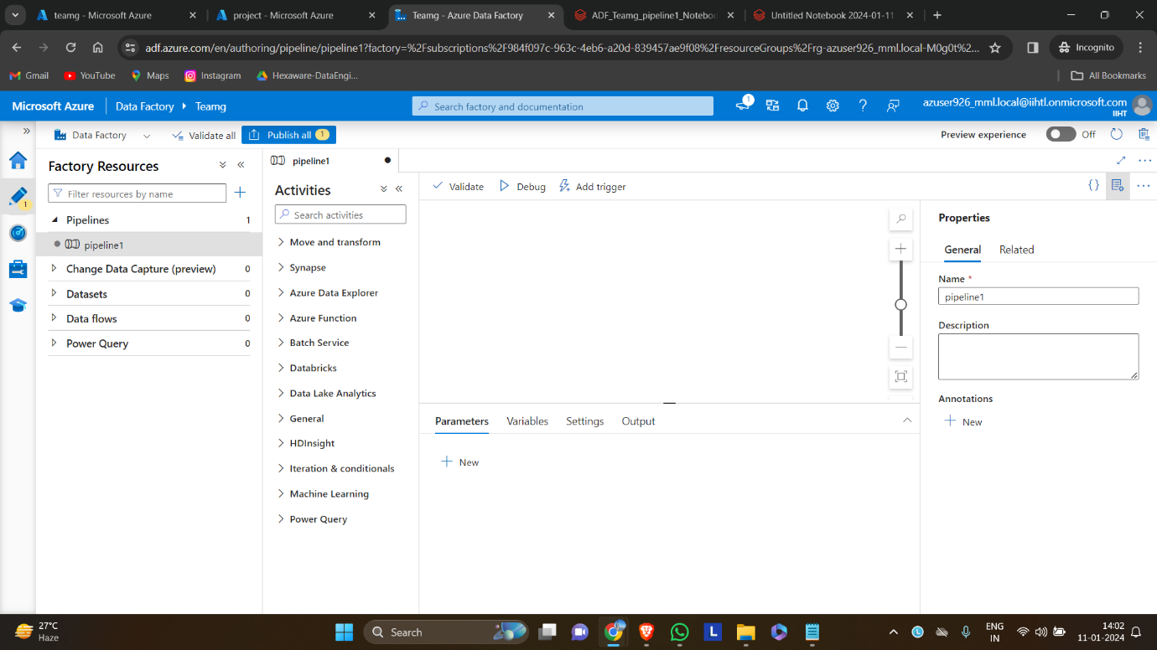

**Step 5:** Drag and drop the notebook icon onto the workspace.

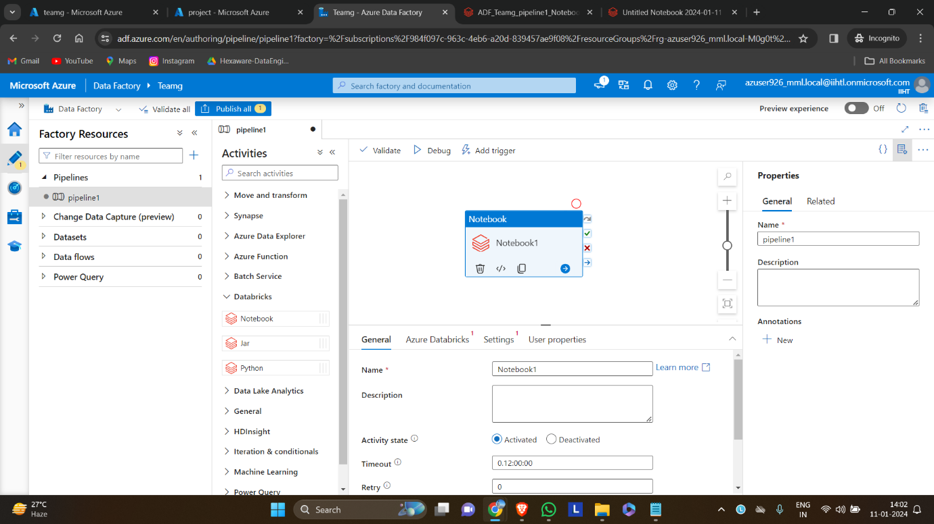

**11.CREATE A DATABRICKS LINKED SERVICE:**

**Step 1:** Select Azure Databricks and click + icon to create a new linked service.

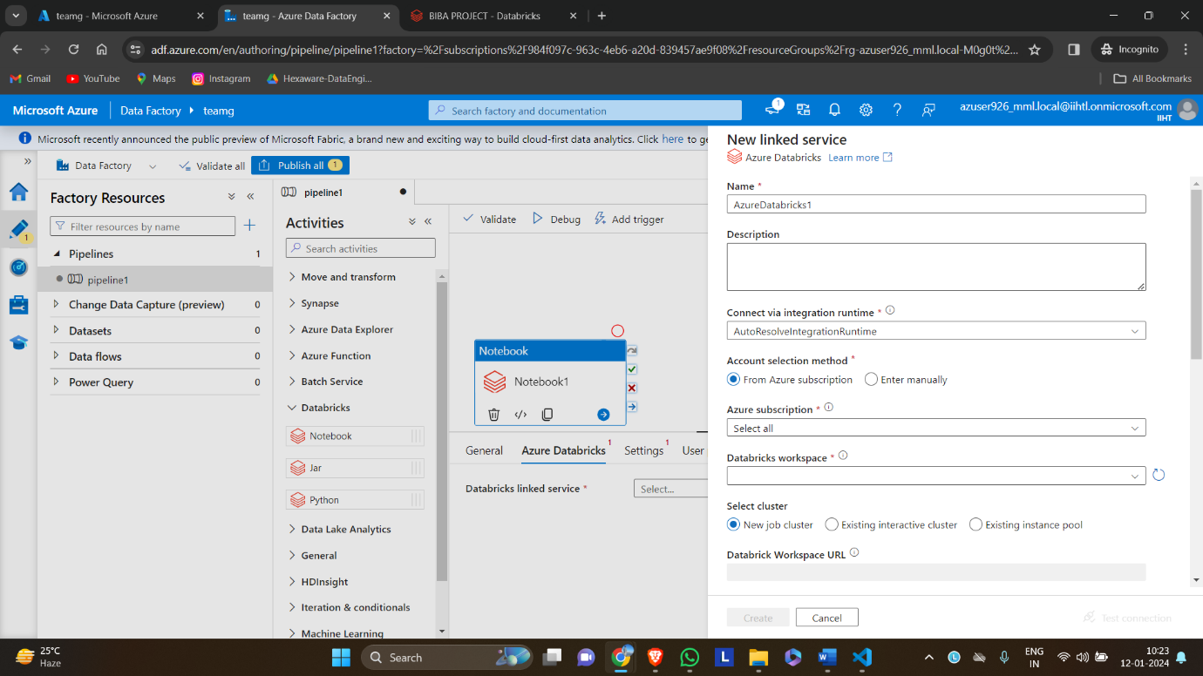

**Step 2:** Give name, select the subscription, select workspace and give its access token to link to the workspace

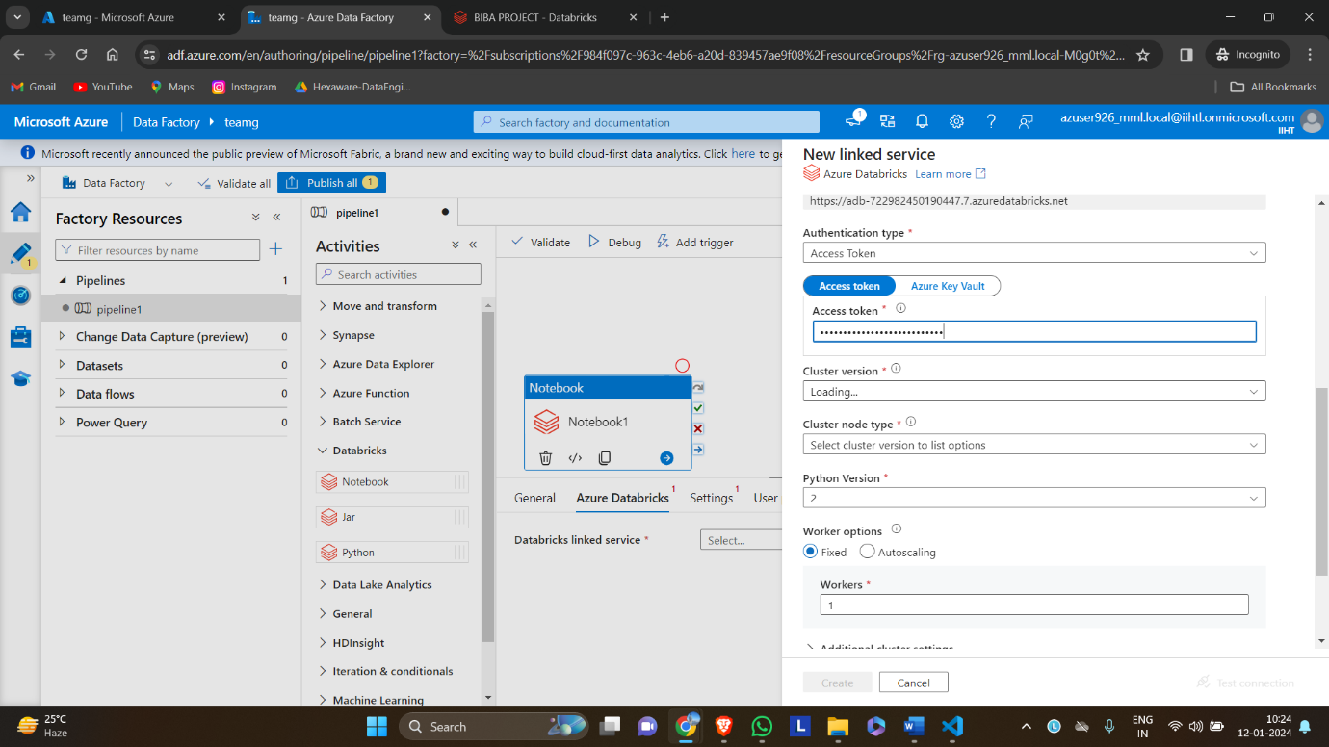

**Step 3:** Access token is taken from azure databricks portal.

* In databricks workspace go to user settings and select developer option.
* Then click generate new token to get access token
* Note: access token can only given once so copy it elsewhere for future use

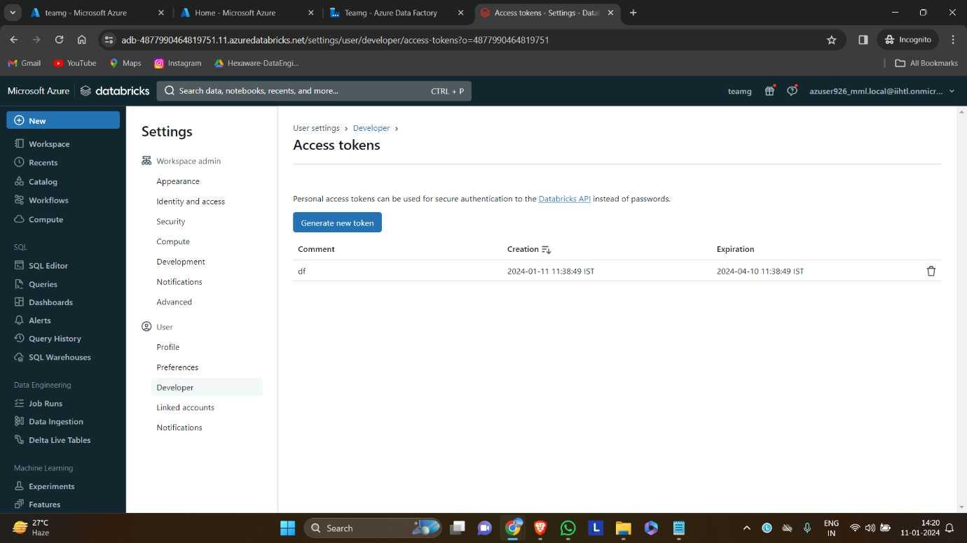

**Step 4:** Select newly linked service to connect to databricks workspace

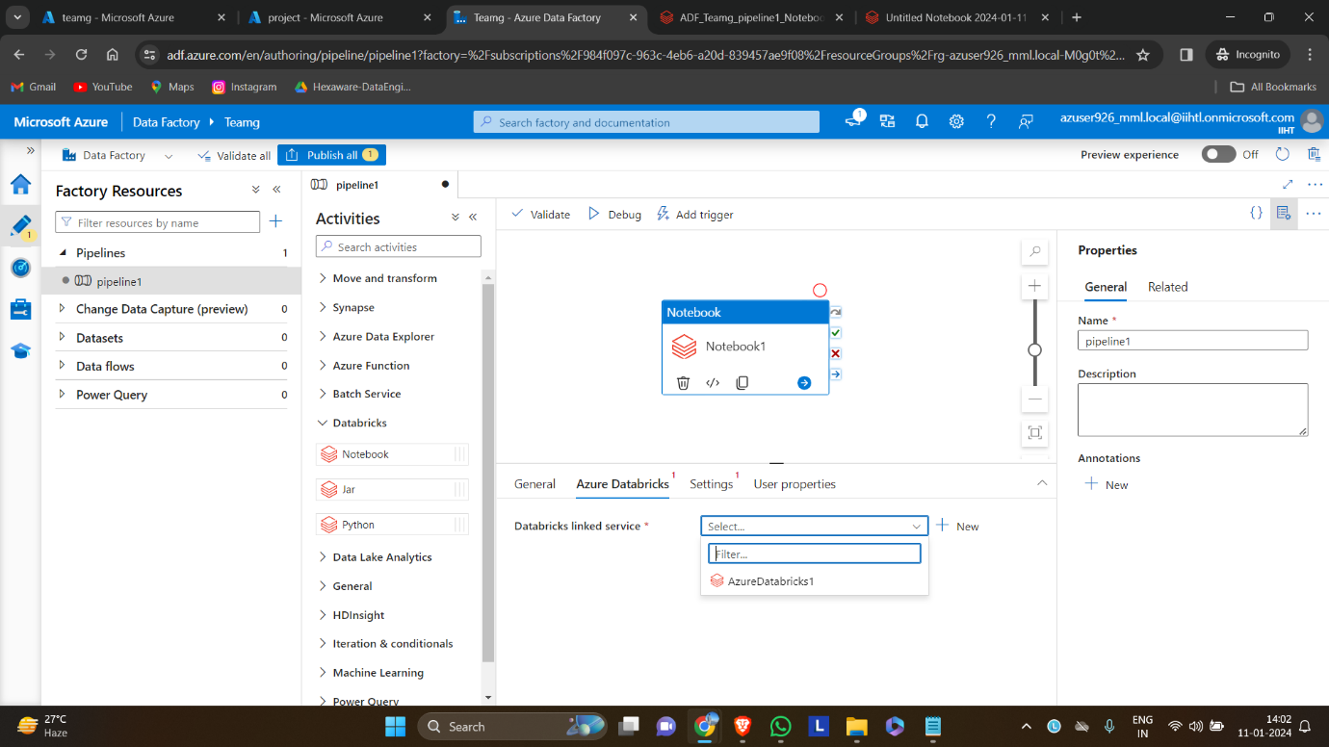

**Step 5:** check connectivity using test connection.

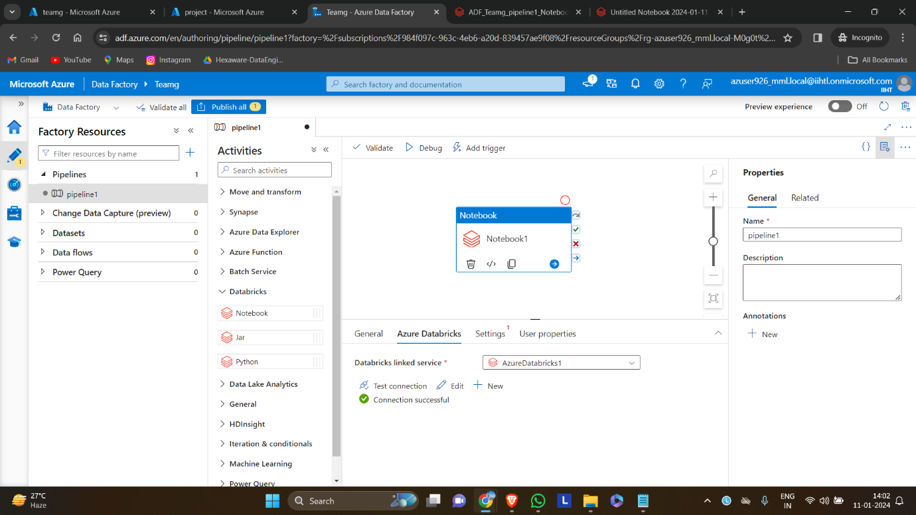

**Step 6:** In settings option select the notebook path to connect.

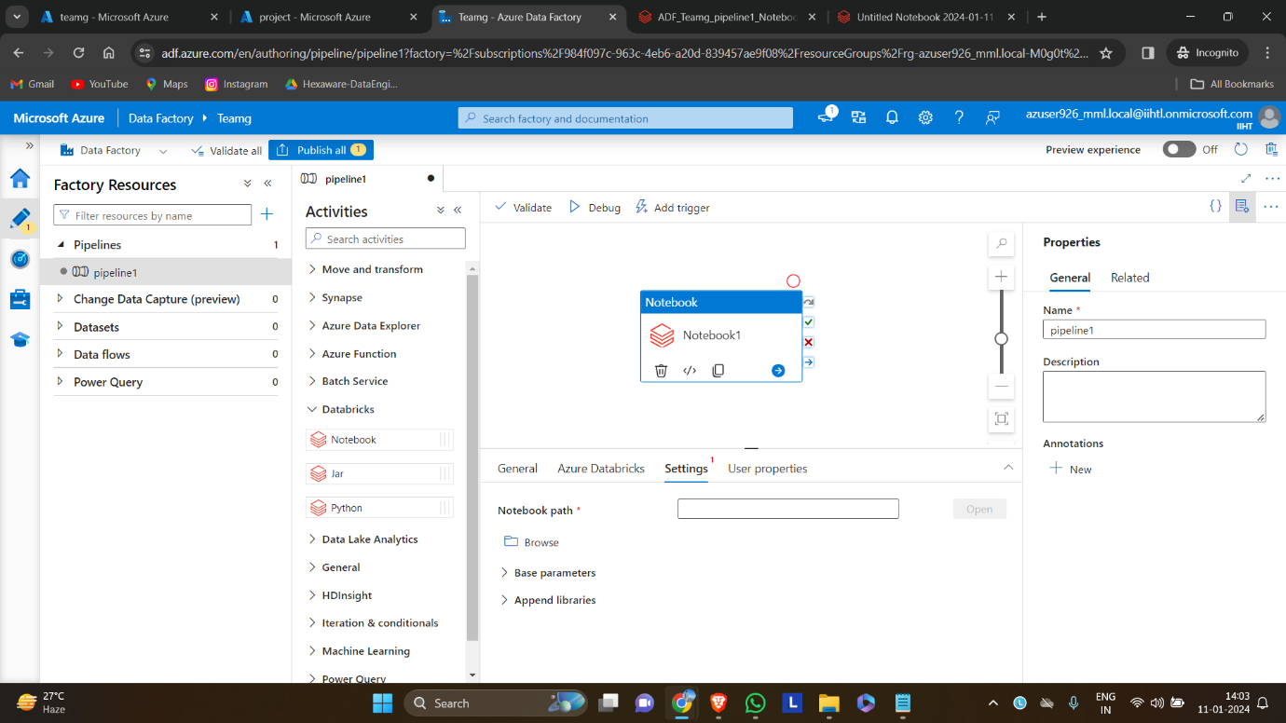

**Step 7**: Select the notebook to used.

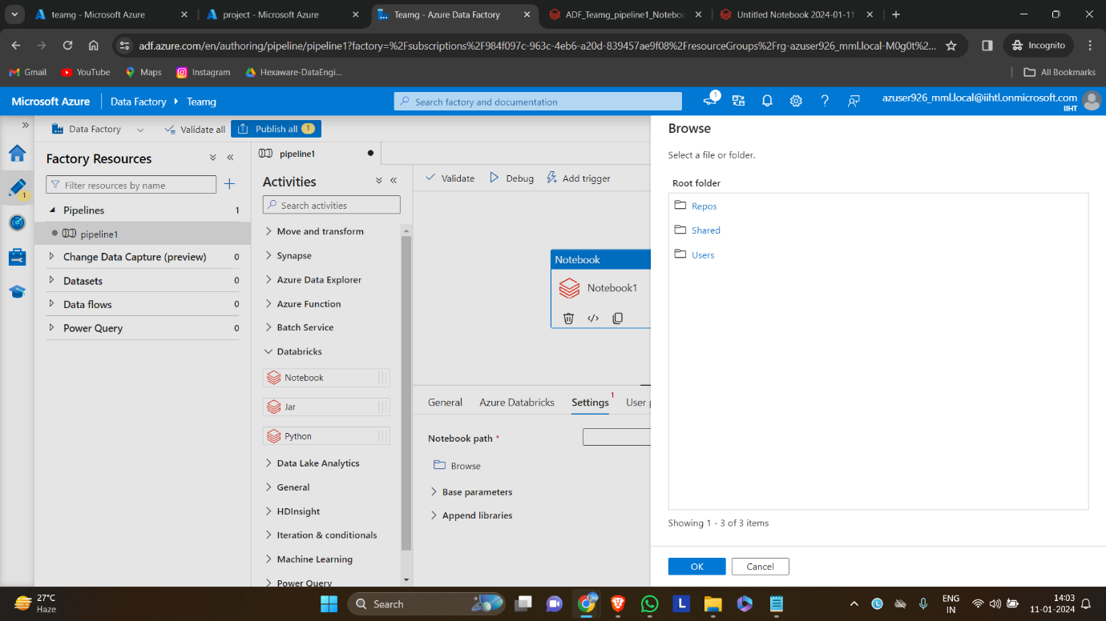

**Step 8:** Validate the pipeline

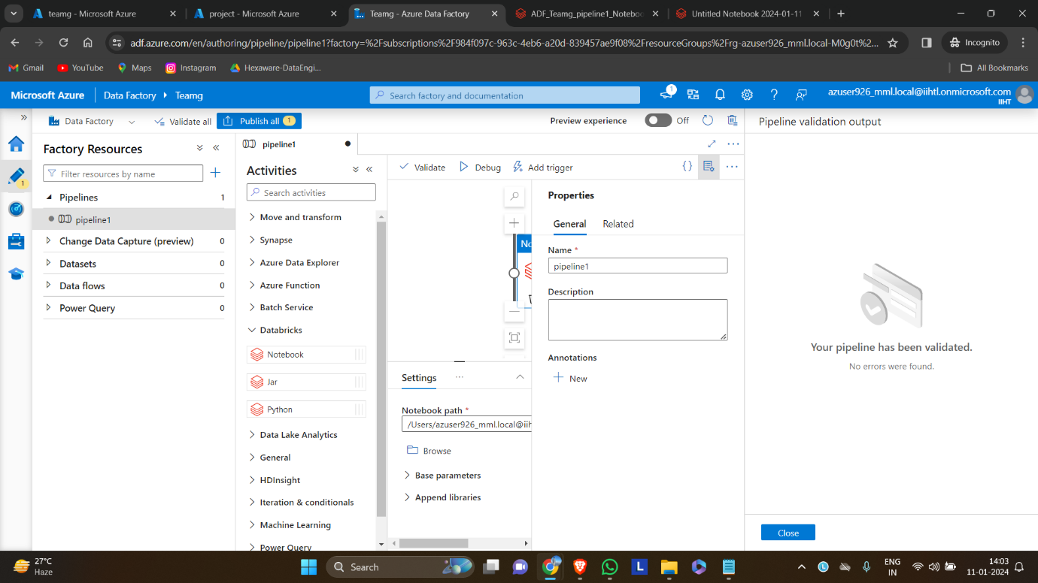

**Step 9:** click debug to run the pipeline to validate the evolving schema notebook

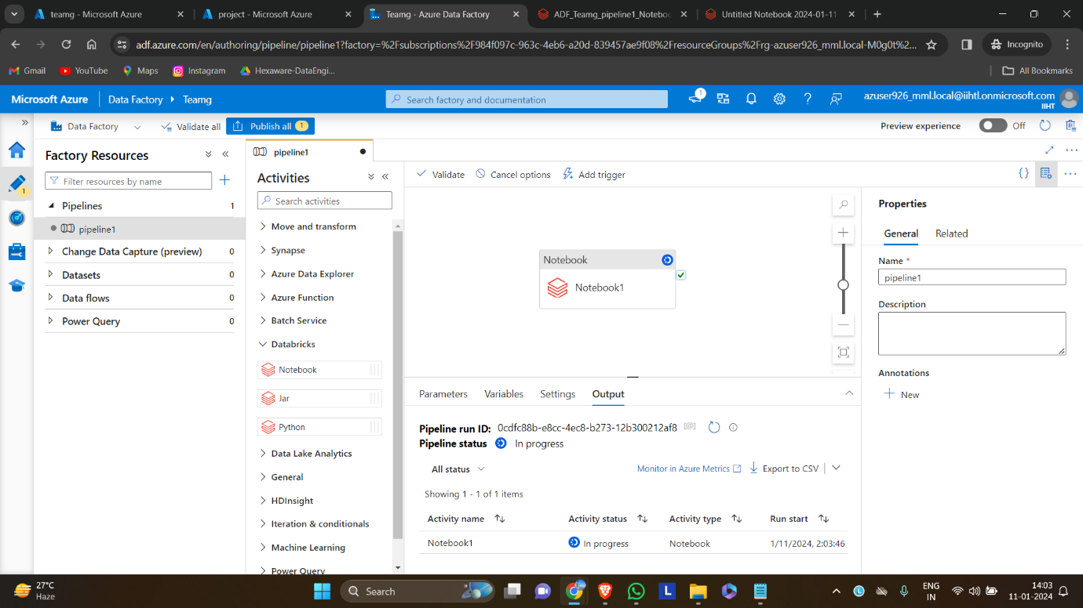

**Step 10:** check the output after running the pipeline.

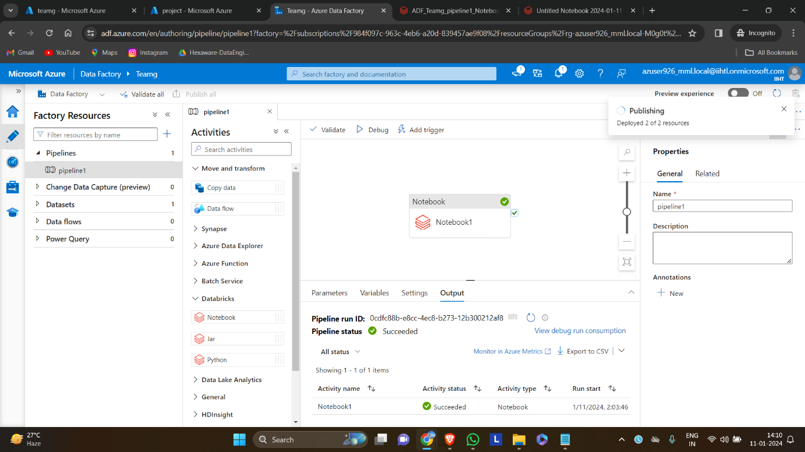

This is the output produced by databricks notebook after running the pipeline.

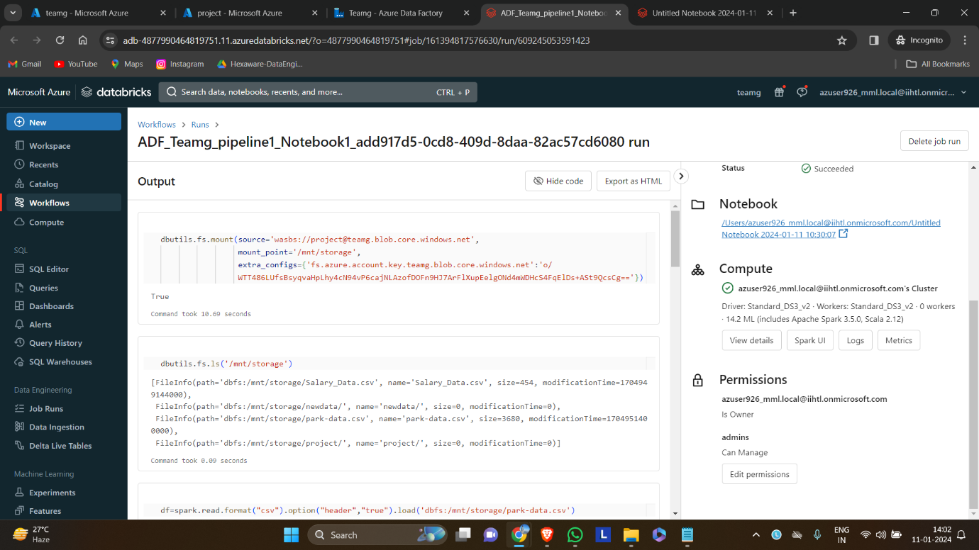

The data that is transformed is stored in the azure storage account

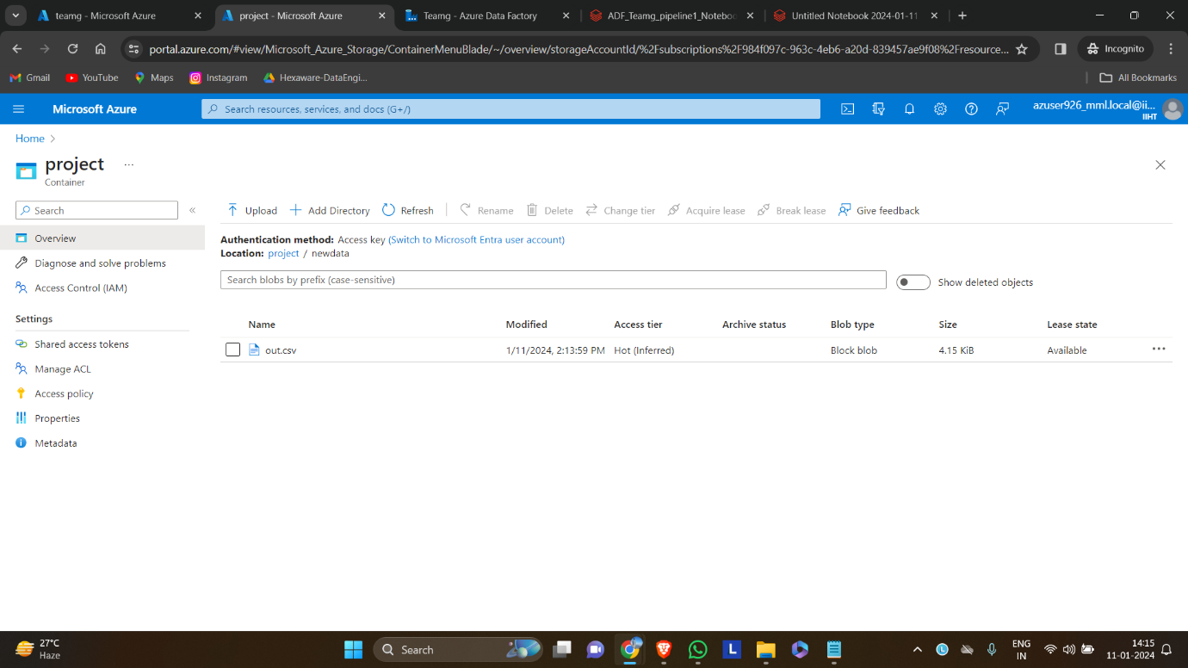

By following these steps, the project establishes an adaptive data processing pipeline where

Azure Data Factory handles schema evolution by moving data to the Data Lake, and Azure

Databricks dynamically adjusts the schema based on the evolving nature of incoming data.